**User Manual**

**Project title:**

Socio- Economic Indicators Portal using Python

**Abstract:**

Socio-economic indicators for different countries are present on different website for agencies like World Health Organization and World Bank. As the data is in different formats, we created a program that will compare and analyze performance of ten socio-economic indicators like GDP per capita, infant mortality etc., for ten South Asian Countries for ten years. Data on the public websites was in the form of API, JSON, CSV or text. So, we used API function call and web scraping to extract and integrate the data. Different packages used during the data extraction process were JSON, pandas.io.json, requests, urlib.request and Beautiful Soup. The final program shows a country’s profile, compare indicators for different South Asia country and allow the user to find the correlation for any two indicators for a country.

**User instructions:**

On running this program, user will be prompted to enter the following options:

1. To exit
2. Know about a South East Asian country
3. Compare performance of South East Asian countries on different indicator
4. Analyze Social and Economic indicators for a South East Asian country

Below is the snapshot of this main menu

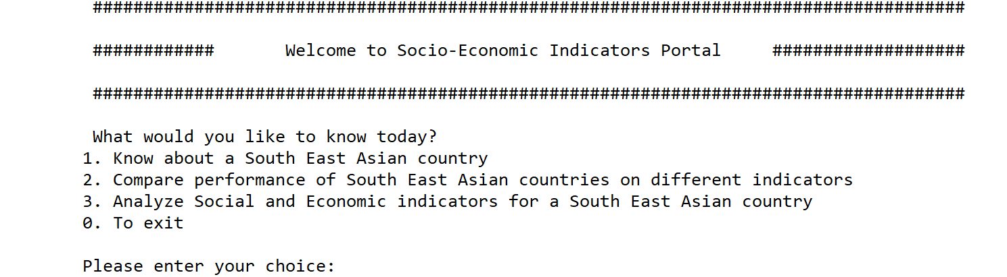

We will explain each option in detail. In order to exit this program, the user needs to enter 0 in the main menu.

**Use Case 1: Know about a South East Asian country**

**Step 1:**

If the user enters 1, the list of the available countries for analysis will be shown as given below:

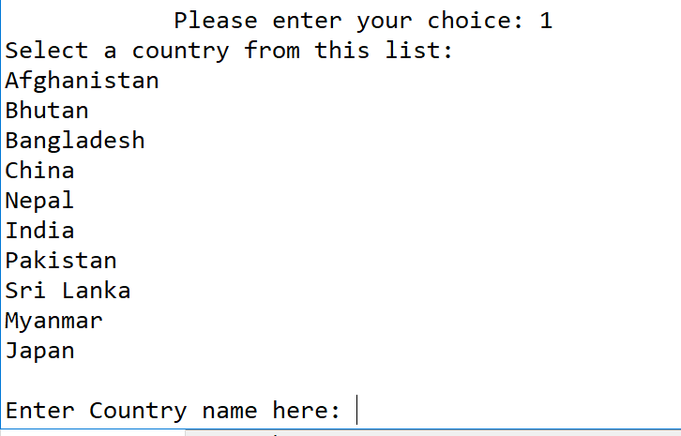

**Step 2:**

The Country Profile will be displayed. Now user has to select from the given menu. Suppose user enters India and presses enter, it will show the country profile and the list of indicator options to choose from as shown below:

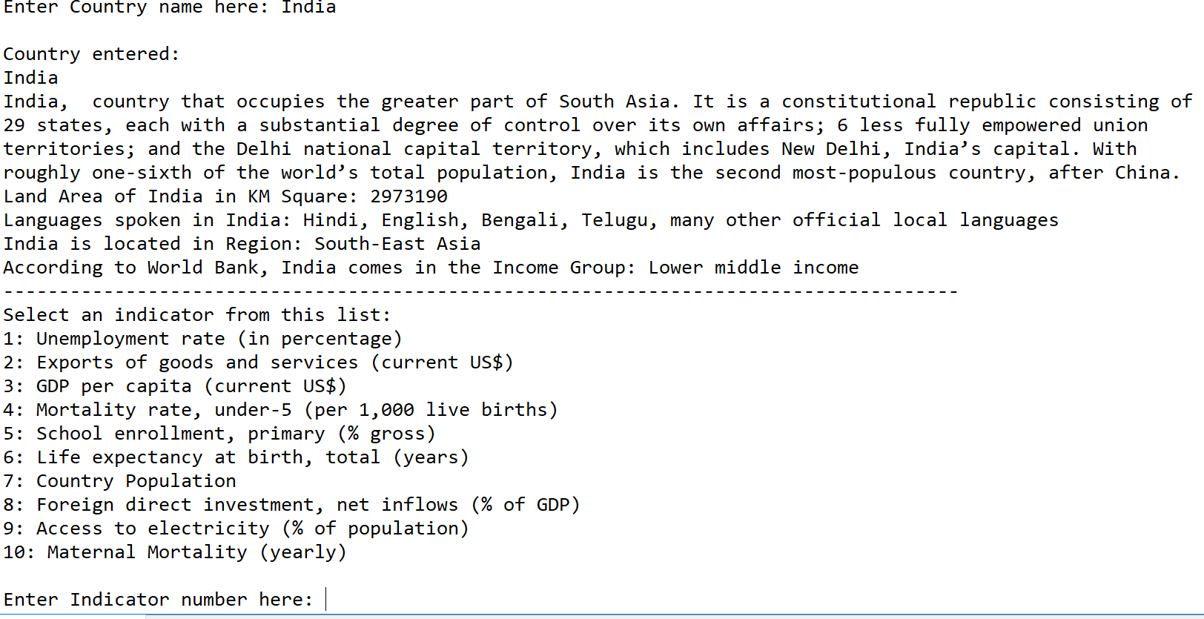

**Step 3:**

User needs to enter a number as specified by the list of indicators, if user enters a number different that the specified list, he/she will get the following error message



If the user enters Yes after this message, the program will prompt the user again to enter the correct number from the list of the indicators as specified earlier

When the user enters the correct list of the indicator, suppose 1 in this case then, it will give graph for that indicator for the specified country as shown in the snapshot below

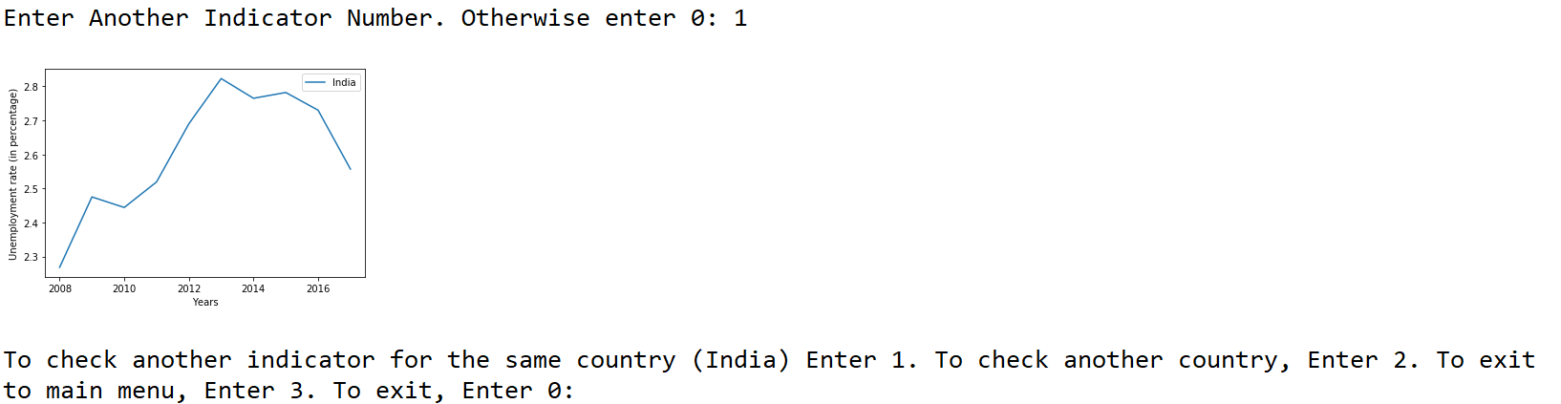

**Step 4:**

User has three options at this point, either to enter 3 to enter the main menu or 0 to exit the program. User can enter 2 to do a similar analysis for another country or enter 1 to check the progress for another indicator for the same country. If the user enters 3, he will go back to the main menu as shown in the snapshot below.

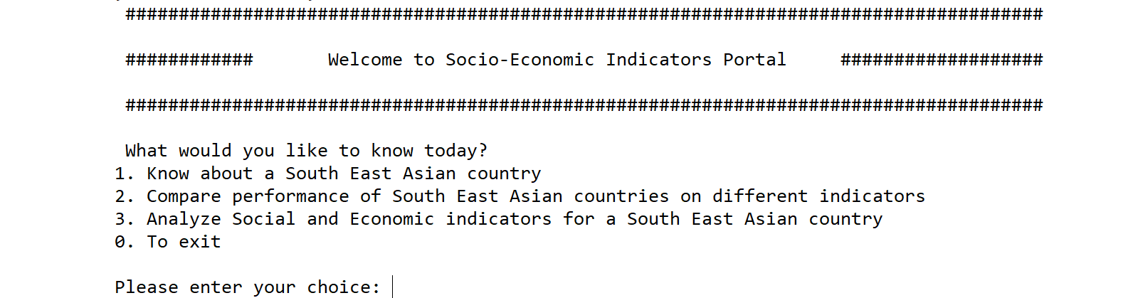

**Use Case 2: Compare performance of South East Asian countries on different indicator**

**Step 1:**

If the user enters 2,the following menu with names of the countries will be shown. In this use case, the user can compare the performance on an indicator for 2 or more countries. It allows the user to enter the names of the countries and while selecting multiple countries, it shows the names of the countries which are already entered.

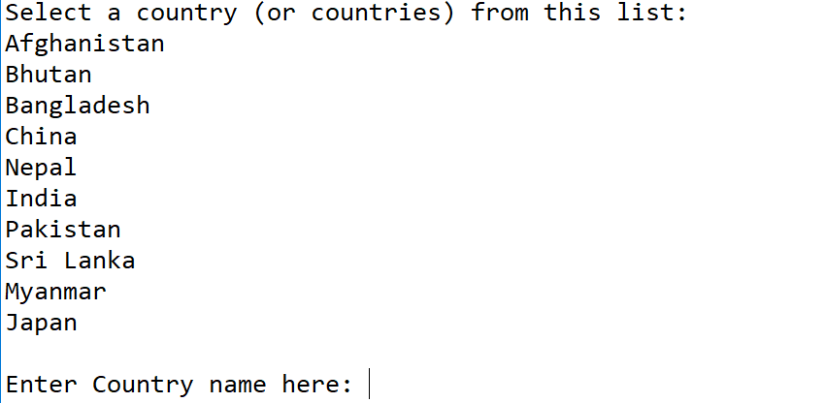

Suppose we enter three names, i.e. Pakistan, India and China, it will show as below

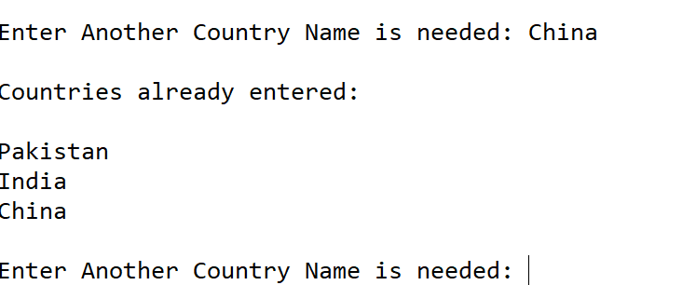

**Step 2:**

When the user enters end, it will show the list of the indicators and prompt the user to select one indicator as shown in the snapshot below

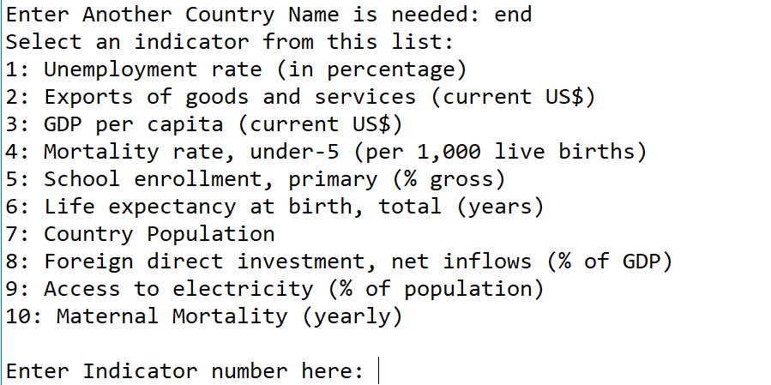

**Step 3:**

Suppose a user selects 1 in this list then the program will draw a graph showing the comparison of that indicator for each country from 2008 onwards

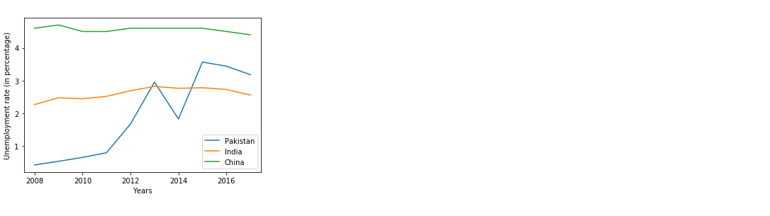

**Step 4:**

Further, the user from this point will have the option to either make different comparison, go to the main menu or exit. Below is the snapshot of this menu



In order go to the main menu, user will need to type 3 and press enter, once done so the program will show the following message

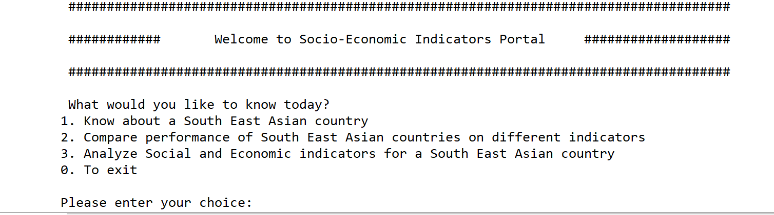

**Use Case 3: Analyze Social and Economic indicators for a South East Asian country**

**Step 1:**

If the user enters 3 in the main menu,a prompt with the list of countries will be shown. The user will have to choose one country from them as shown below

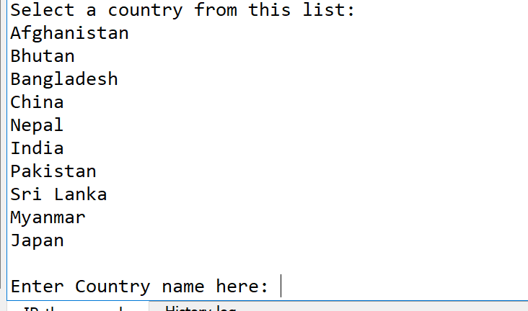

**Step 2:**

Suppose the user enters Pakistan, he/she will get a list of indicators and the user will be prompted to choose indicators for comparison from the list of indicators as shown in the snapshot below:

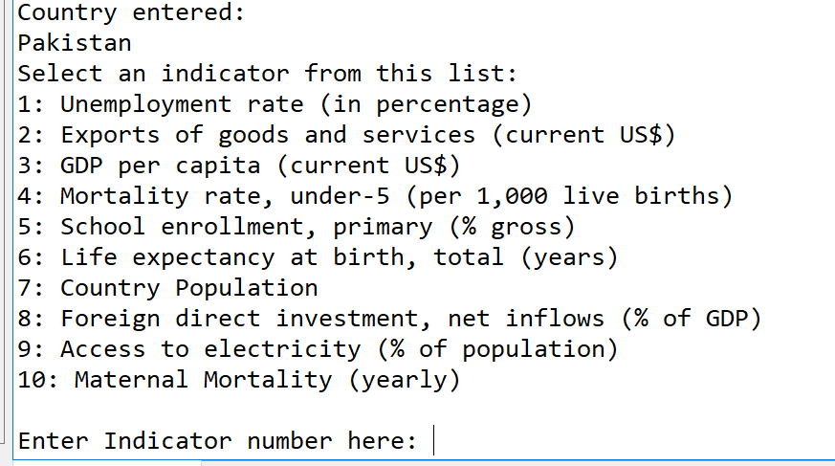

**Step 3:**

If the user enters the first indicator, the user will be prompted again to enter the second indicator. And once done a graph will be shown showing the correlations between the two selected indicators for the selected country. Below is the snapshot in case user selects indicator 1 and 2

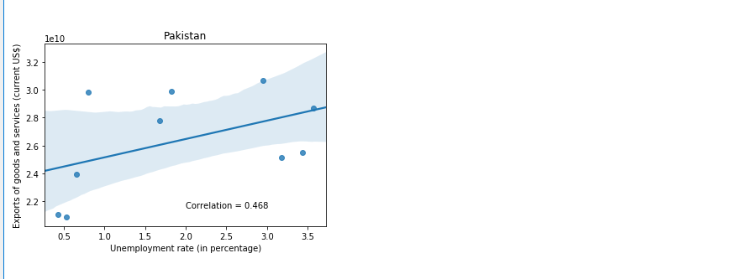

**Step 4:**

Finally, the user will be prompted with the message as shown below, asking to whether analyze different indicators for the same country or analyze a different country or go back to the main menu or exit the program. Incase the user wants to exit the program, he/she can type 0.

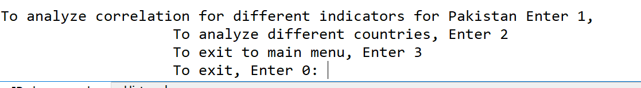

By typing 0 user can exit the program.

****End of document****